TASE Data Download Description

1. Auto-Download of Daily data files from https://www.tase.co.il/TASEEng/MarketData/RawData/FileDistribution.htm
and saving in MetaStock data files:

Set up the main screen as shown:

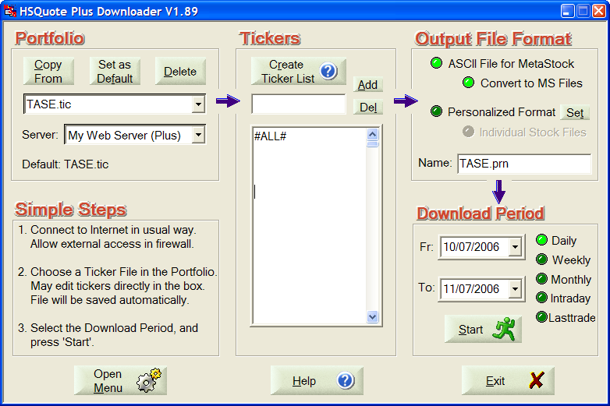

Take note of:
- Portfolio name is “TASE.tic”. It can be changed, but you will need to change the corresponding line in the “mywebserver.txt” file in the program installation folder to the same portfolio name.
- Server: My Web Server (Plus).
- Choose “ASCII File for MetaStock” and “Convert to MS Files”.
- You may use “Daily” or “Lasttrade” mode to download, but the “To:” date is the only date used to identify which day of data to download (Fr date is ignored). Note that you should download at the end of the day when data has become available.
- In the “TASE_DL4.fmt” file, procedure has been set up to auto-create ticker list. You can put “#ALL#” on the first line, and make sure that the “To:” date has data, click on the “Start” button. You will see that the tickers are created in the first pass, then the data are downloaded in the second pass.
- Since ticker list can change, you may want to do #ALL# procedure once in a while to refresh the list.

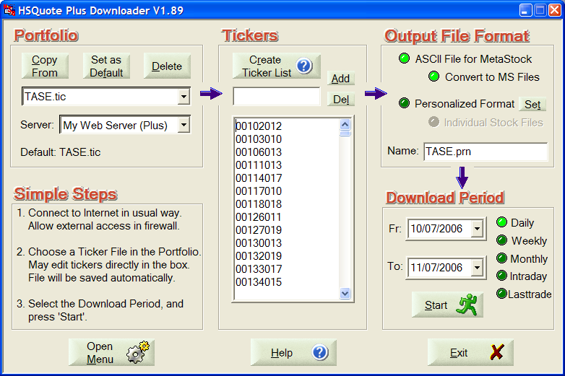

2. Download Daily ZIP file from
https://www.tase.co.il/FileDistribution/PackTarget/FullYYYYMMDD0.zip
and saving in user defined folder

Approach #1: Auto-download the ZIP file right daily download of data:
- We need the “PostDownloadProcessing.xls” file to use the Post-Download-Processing feature. This file has been done for you to do two actions:
- EXECUTE action in row 2 with the URL link given in cell E2 https://www.tase.co.il/FileDistribution/PackTarget/FullYY4YMMMMDDDD0.zip will fetch the zip file from the IE browser.
- SAVEZIP action in row 4 simulates key presses to automatically save the downloaded file. Do not click on anything when this is running. (I do not know whether you are using English version of Windows. If not, the open dialog window may not have the title line as “File Download”. If this is the case, please let me know what it is, and I will change the code accordingly. If you don’t see the dialog window at all, you must have turned it off. Go to Windows Explore, click on View >> Folder Options >> File Type tab >> find ZIP extension >> Advanced >> check "Confirm Open after download")

- To use the Post-Download-Processing feature, you must go to “Open Menu >> Preference” and click on the “Other Options” button. Then check the “Do post download processing (HSQuote Plus Only). Remember to uncheck it if you don’t want to download the ZIP file after data download.

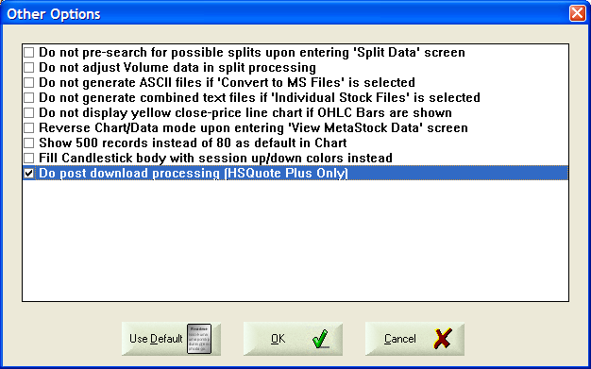

Approach #2: Manually download the ZIP file:
- Just click on “Open Menu >> Charts, Data and News >> Group 1”. Today’s ZIP file will be downloaded. You will click on Save button to save the file.
- Note that I have created the URL link in Chart/Data/News 1 of the Preference page. Click on the Change button and you see that Group 1 default is “TASE”.

Both approaches assume that you have selected which folder to store the ZIP file. If you have not selected the folder, please use Approach #2 (manual mode) to select the folder location. Once done, Windows Explores remembers it.

